Experiment 6

OBTAINING THE INHERENT CHARACTERISTIC CURVES OF A SEPERATELY EXCITED DC MOTOR

# PURPOSE OF THE EXPERIMENT

Purpose of this experiment is to learn the working principle of dc motors, different excitation methods and obtain the inherent characteristic curves of a dc motor.

# CONNECTION DIAGRAM

//çizildi

# Explanatıon of Experıment

In this experiment, a DC motor is drove. Driving a DC motor is easy, its speed can be easily adjusted and a DC motor can generate high torque. But on the other hand, a dc motor can be relatively big compared to an AC motor at same power levels. Also a DC motor requires maintenance in its brushes and can be frequently malfunctioned.

Starting of a DC motor is important because at starting, DC motor has no rotation and electromotive force therefore DC motor’s armature windings can draw high currents according to following equation;

Ia = Va/Ra (works as a RL circuit)

Also this transient can create voltage and current spikes in the interconnected network. To avoid this occurrence, an additional resistor is used serial to the motor. At starting, this resistor value is adjusted to its maximum, then in time it is decreased.

First part of the experiment, changing the excitation current, speed of the motor is measured while the armature current is constant. Using this measurements no-load inherent characteristic curve is obtained (graphic 1).

In second part, excitation current is kept constant and load on the motor is increased gradually. Torque and speed values obtained (graphic 2). Torque is calculated using several masses and a 1 meter long rod attached to the motor. Using following equation;

Md = 1m*g/1000 gram based masses are used

In third part of the experiment, rotational speed is kept constant with adjusting the excitation current while the load on the motor is increased. Armature and excitation currents are obtained (graphic 3).

//ölçümler

Montaj şeması

Ölçümler

Ölçü aletleri ve kullanma şekli

Motora yol verme

Hız ayarı

Dikkat edilmesi gereken yerler

Grafikler

//ölçümler

//bağlantı şeması

//yapılışı

//denklemler

# QUESTIONS

1. 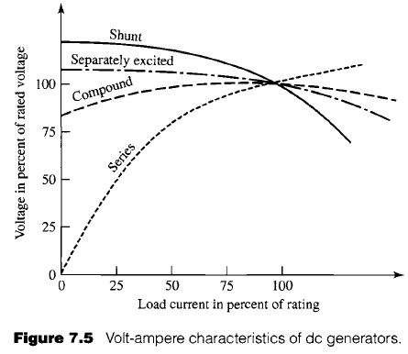



1. To avoid the runaway in a DC motor, a parallel relay can be connected to control the armature current with the cut-off excitation current. When the excitation current is cut, automatically armature current is cut-off.
2. S
3. In this situation, shunt current is cut, therefore only series winding is present. Motor continues to rotate but excitation current decreases therefore armature current and speed decreases.
4. 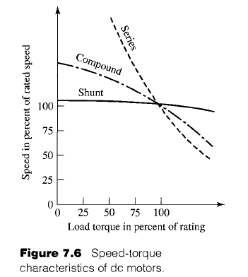When we look at the speed-torque characteristic of a dc motor, it can be seen that in lower speeds a series DC motor can provide very high torques. It is reasonable to use a series dc motor in a tram.
5. Nom current = 30 A volt = 220, 220/30 = 7.33 ohm 7.33-0.5 = 6.63 ohm

# RESOURCES

FITZGERALD, A., E., KINGSLEY, C., Jr., Umans, S., D., Electric Machinery, 6th edition, Mc-Graw Hill, Pg. 360-363

Levent Ovacık Lecture Notes